Possessive Modifier

🔹 What Is Interrogative Modifier?
# Source: AI Source: Provided by: [Data Path: Persons Table -> ID Column: 1, Name_En Column: Motasem Essam] -> From: [Chatgpt (GPT‑5 Mini)] on [8/7/2025]
A possessive modifier is a word or phrase that shows ownership or relationship and modifies a noun by indicating who or what something belongs to.

🔸 Forms of Possessive Modifiers:
# Source: AI Source: Provided by: [Data Path: Persons Table -> ID Column: 1, Name_En Column: Motasem Essam] -> From: [Chatgpt (GPT‑5 Mini)] on [8/7/2025]
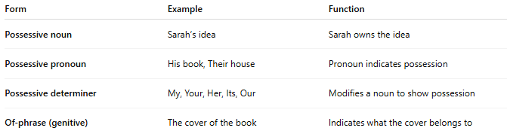
Form | Example | Function
Possessive noun | Sarah’s idea | Sarah owns the idea
Possessive pronoun | His book, Their house | Pronoun indicates possession
Possessive determiner | My, Your, Her, Its, Our | Modifies a noun to show possession
Of-phrase (genitive) | The cover of the book | Indicates what the cover belongs to

🔸 Examples in Sentences:
# Source: AI Source: Provided by: [Data Path: Persons Table -> ID Column: 1, Name_En Column: Motasem Essam] -> From: [Chatgpt (GPT‑5 Mini)] on [8/7/2025]
- John’s jacket is on the chair. (possessive noun)
- My phone is charging. (possessive determiner)
- Is that her decision? (possessive pronoun)
- The tail of the dog wagged quickly. (of-phrase modifier)

🔸 Key Notes:
# Source: AI Source: Provided by: [Data Path: Persons Table -> ID Column: 1, Name_En Column: Motasem Essam] -> From: [Chatgpt (GPT‑5 Mini)] on [8/7/2025]
- A possessive modifier always comes before the noun it modifies.
- It can also be expressed through a prepositional phrase (especially with "of").
- It shows relationship, ownership, or association.

